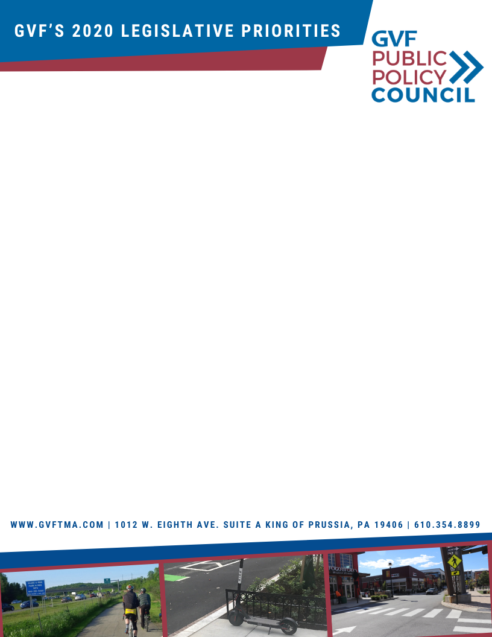

**Our residential population is double**

the Cities of:

**Nashville, Portland, Las Vegas, Baltimore, Atlanta, and Miami**

Our residential population is also **77% larger** than the City of **Pittsburgh**

GVF has been recognized as the **Best TMA in the United States**,

by the

National Association for

Commuter Transportation

In 2019, through our press, email, social media and website campaigns, we reached over

**10,000,000** **people**

In 2019, the shuttle systems that GVF managed **prevented over 300,000 vehicle miles**

on our roadways

**Our service area has a population larger**

than the Cities of:

**Dallas, San Jose, Austin, San Francisco, Seattle, Denver, Washington D.C. and Boston**

If you look at the surrounding counties and the City of Philadelphia, there are over

**4 million residents** who live and commute throughout Southeastern PA

**Celebrating its 30th anniversary, GVF is a non-profit, Transportation   
Management Association (TMA), who works with the public and private sectors on advocating and**

**promoting a viable transportation network for the region's economic vitality.**

**BY THE NUMBERS:**

**According to the NY Times, the Philadelphia metro region has experienced a 22% increase in auto emissions since 1990. In order for this region to remain economically competitive, we cannot build our way out, rather we need to be developing creative solutions to reducing congestion. To advance this agenda, GVF has developed several legislative priorities:**

Through our Annual TDM Awards Program, we’ve given out over   
**250 recognitions which represents over 600,000 commuters**

As of 2019, GVF works in an area with roughly

**1.33 million**

residents

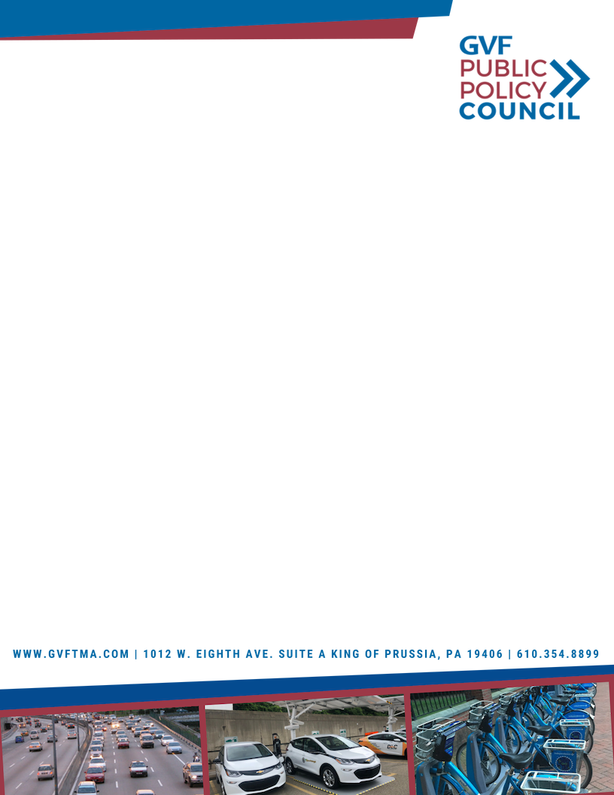

**Funding:** Work with federal and state lawmakers to find creative solutions to provide

adequate funding for transportation infrastructure, including mass transit and trail

connection.

**Implementation of TDM programs:** Transportation Demand Management, or TDM,   
are strategies that focus on how we manage the transportation system to alleviate congestion;

whether through transit, cycling, ITS, GVF partners with both the public and private sectors to

provide their employees with tools, resources, and education on how to implement

these programs.

**Innovation:** GVF is collaborating with national, regional and local entities to bring new technologies

to the region and the commonwealth that will improve mobility options.

**Partnerships:** Work with business improvement districts, chambers of commerce, corporations, elected officials, educational institutions, engineering firms, financial institutions, hotels, law firms, local, state and federal governments, medical institutions, national park services, real estate developers, retail and entertainment operators, special services district and transit providers to ensure a 21st century infrastructure program.

1. **LEGISLATIVE PRIORITIES FOR PENNSYLVANIA:**

* Further investment in **Transportation Demand Management (TDM)** programs
* Formation of a **state-wide TDM committee**
* Continued **investment in infrastructure** throughout Pennsylvania
  + Emphasis on the current maintenance of the transportation system
  + Increase transit funding
* Priority projects:
  + King of Prussia Rail
  + Transit alternative along Route 422 Corridor
* Amend the PA vehicle code to **integrate emerging technologies**
* **Focus on environmental impact** to the system and encourage reduction in SOV trips